Newsletter Volume 1, Edition 1, June 2024
"ACTION FOR JUSTICE" Project Kicked off
अवधारणा
नेपाल अपाङ्ग महिला संघले CBM Global Nepal को साझेदारीमा अपाङ्गता भएका महिला तथा बालिकाविरुद्ध हुनेहिंसा Sexual and Gender Based Violence-SGBV अन्त्यको लागि सन् २०२४-२०२७ सम्म बुढानिलकण्ठ नगरपालिका र तारकेश्वर नगरपालिकामा मे, २०२४ देखि “Action for Justice” परियोजना सञ्चालन गरेको छ । परियोजना अन्तर्गत पालिका तथा संघीय तहमा अपाङ्गता भएका महिला तथा बालिकाविरुद्ध हुने सबै खाले यौन तथा लैङ्गिक हिंसा अन्त्य गर्ने अभियानमा अपाङ्गता भएका नेतृत्व तहका महिलाहरुको क्षमता अभिबृधि गरिने छ । साथै हिंसा प्राभावित अपाङ्गता भएका महिला तथा बालिकाको लागि कानुनी सहयोग र मनोसामाजिक परामर्श सेवा

सहित न्यायमा पहुँच छ ।
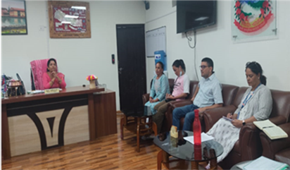

Unique Aspects of the Project
"Action for Justice" stands out in both its issues and stakeholders:
- Issues: The project uniquely promotes and emphasizes accessible justice and protection for women and girls with disabilities against SGBV, a relatively new focus in our context.
- Stakeholders: The project engages a diverse range of stakeholders, including duty bearers, rights holders, and facilitating organizations. Each stakeholder group plays a crucial role in achieving the project’s intended results, ensuring collective ownership and commitment.
Looking Ahead
We are excited about the potential impact of "Action for Justice" and remain committed to advocating for and securing the rights of women and girls with disabilities.

"securing accessible justice for women and girls with disabilities who are survivors of gender-based violence (GBV)"

Workshop on Detailed Implementation Plan DIP
Nepal Disabled Women Association, NDWA has prepared a Detailed Implementation Plan (DIP) for the next four years to work for Action for Justice (A4J) for Sexual and Gender based Violence of women with disabilities on June 13 and 14, 2024 in Kathmandu.
The Detailed Implementation Plan (DIP) development workshop was conducted by organizing a two-day workshop with the participation of the officials and members of the executive committee of the Nepal Disabled Women Association and its staff. Technical support was also received from the CBM Global to prepare DIP

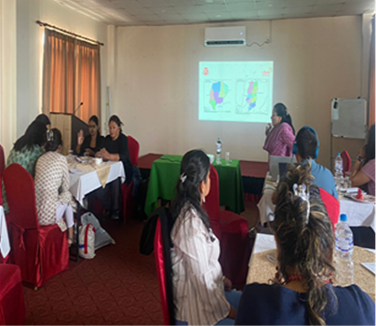
The Action for Justice (A4J) project will focus is aimed at securing accessible justice for women and girls with disabilities who are survivors of gender-based violence (GBV).
The program will provide support to service facilities and physical structures of public service agencies and service providers established in the community to federal level providing justice to SGBV survivors in accessible way.
NDWA will collaborate with ministries, Justice committee, OCMC, police, women cell, civil society organizations and OPDs during implementation of this program.
Meena Paudel VC of NDWA Sharing a project detail in the workshop

Legal awareness program in Tarakeshwar Municipality
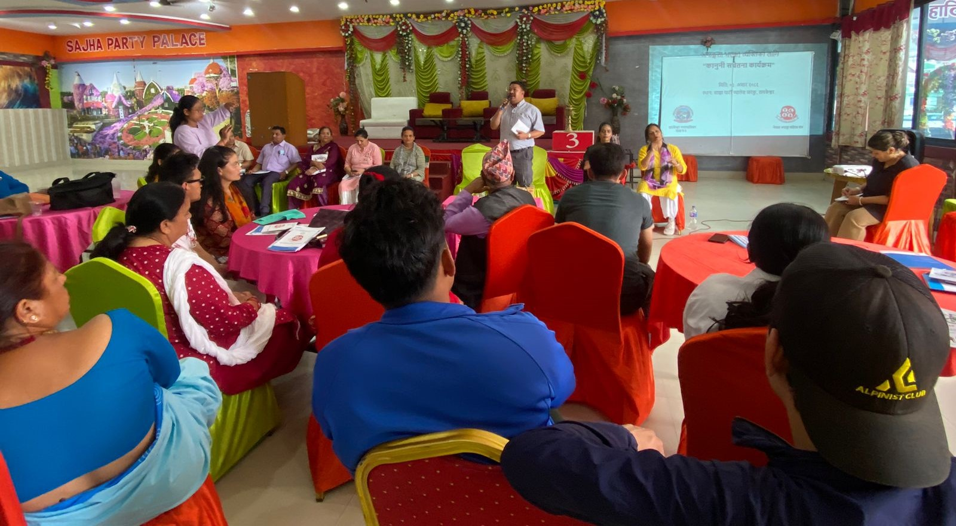
Ward no 2 chairperson of tarakeshowre Radhakrishna Khadgi sharing the facility provided by ward

Nepal Disabled Women Association organized a legal awareness program for women with disabilities on June 17, 2024, in Tarakeshwar Municipality Ward Number Two.
63 persons with disabilities, women health volunteers, ward representatives, and family members were participated in the program organized by the NDWA with the support of Tarakeshwar Municipality Ward Two.

Speaking at the program, Radhakrishna Khadgi, Chairperson of Ward No. 2 and spokesperson of, said that the person with disabilities and service providers in the ward should know about the existing service facilities and legal provisions for the rights of persons with disabilities. He informed the program that the school built in his ward was made accessible and the toilet which is currently building will also be made accessible.
He said that person with disabilities need opportunities more than kindness, and he promised to take the initiative in creating these opportunities based on their abilities and capabilities in his ward.
Persons with disabilities participating in the program shared their experiences about the obstacles and barriers they are facing based on their disabilities.
In the event, Tika Dahal, Chairperson of NDWA, presented the existing laws, policies, and provisions for persons with disabilities and General Secretary Dev Kumari Parajuli about the types of disabilities and the services they are getting from the government.

Make health facilities accessible: NDWA
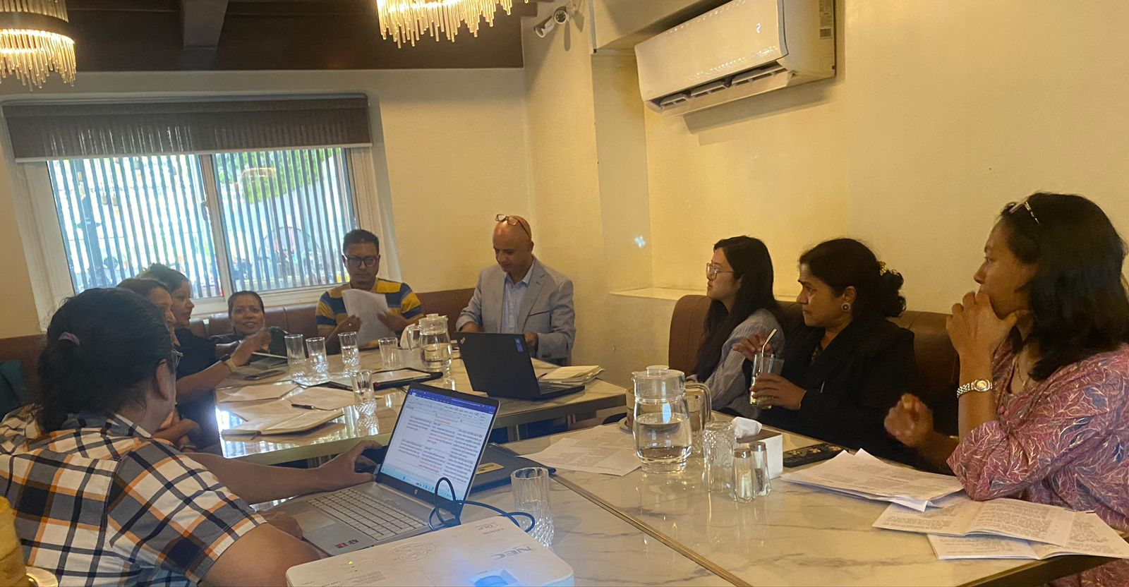
Participants discussing on SRHR policy presented by the consultant

The Nepal Disabled Women Association NDWA in partnership with UNDP has finalized the review of the Sexual and Reproductive Health Rights Act on June 28, 2024. NDWA finalized the revision of the Act on accessible services from the perspective of women with disabilities after discussing with the different experts and stakeholders. They recommended that issues such as disability-inclusive and accessible services, accessible, disability-friendly services and information should be included in the act. NDWA will submit finalized 'tin mahale' with the recommendations to the related ministries and parliamentarians.

Participated in the Municipal Council of Tarakeshwar
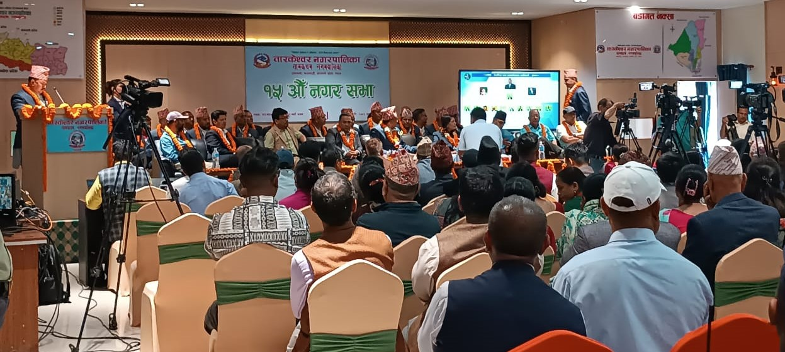
Local level representative in the Municipal Council of Tarakeshwar Municipality

The representative of Nepal Disabled Women Association has participated in the Municipal Council of Tarakeshwar Municipality on June 21,2024. NDWA has started a program against Sexual and Gender based violence (SGBV) women and girls with disabilities in this municipality from 2024 to 2027.

Capacity Building Training on SGBV Response
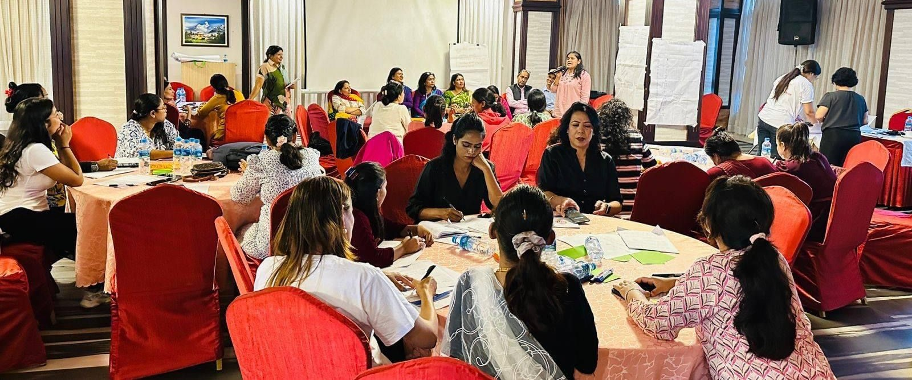
Participants sharing views in the training session

Anita Lama, deputy mayor of Budhanilkantha Municipality, informed that the municipality is going to appoint a sign language interpreter in the municipality from this fiscal year. Speaking at the opening session of the capacity-building training organized by the Nepal Disabled Women Association in partnership with CBM Global Nepal, she said that an interpreter will be under the judicial committee of the municipality. She further added that a budget has been allocated for persons with disabilities in each ward this year as well. She added. "Policies and programs for the target groups are planned and implemented but hard to get results as we spent budget, so, the budget and policy program for persons with disabilities have been more institutionalized from this year."
Likewise, while speaking at the closing session of the training, the Deputy mayor of Tarakeshwar Municipality, Srijana Burlakoti, said that she wanted to work for the person with disabilities from day one after she won as a deputy mayor. She also committed to being ready to work in every field of disability and to facilitate it in the coming days.
Three-day capacity-building training on inclusion of people from underrepresented groups & SGBV response including the supported decision-making, to the project team, NDWA's SGBV response group, NDWA's members, & key OPD representatives was organized from 30 June to 2 July 2024.
Various agendas like identification and rights of underrepresented groups, disability inclusion, concept and types of gender-based violence, concept of disability and response to violence, UNCRPD provisions focused on women and girls with disabilities and sexual and gender-based violence, access to justice, case management, leadership development of women with disabilities, were raised in the sessions.
Methods like interaction, group work, and presentation were adopted during the session. Participants seemed very curious about the training and raised issues, shared experiences and incidents they had faced were shared in each session.
Participants shared that they were able to gain awareness and knowledge about gender-based violence, supportive decision-making process, inclusion of underrepresented communities, legal capacity, and empowering them to make their own decisions.
Thirty-two women including executive committee members of NDWA, staff, and different OPD representatives participated in the training.

Nepal Disabled Women Association (NDWA), Kalopul, Kathmandu, Phone: 00977-01-4435131, Email: ndwa.2009@gmail.com, Website: www.ndwa.org.np

